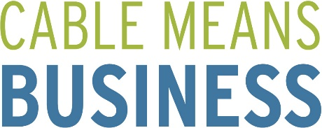
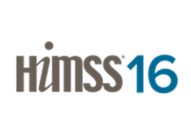

Booth 7830
Comcast Business provides customized technology solutions that are Built for Healthcare. Our advanced Data, Video, and Voice Services, along with our Managed Solutions, give healthcare organizations enterprise-grade technology from a single provider, on a smarter network. Visit Comcast Business booth 7830 to experience our interactive displays, check out our speed test demo and learn about an exciting new concept we are pioneering to extend patience care to the home.

Booth 4400 / T2113
Cox Business provides reliable and secure network connectivity to support the critical priorities for healthcare providers today. Our solutions are about enhancing patient care outcomes, improving operational efficiency and boosting financial returns. We aim not only to provide a secure, reliable network infrastructure, but also to become a trusted partner, helping customers optimize networking service strategies. Visit Cox Business (Booth 4400) for a product demo.

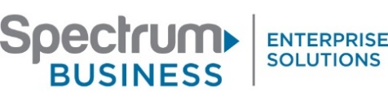
Booth 12340
Spectrum BusinessTM Enterprise Solutions provides connectivity to power the continuum of care by delivering enterprise-grade solutions that drive your Business Continuity and Disaster Recovery, Cloud, Data Center and Big Data initiatives over our reliable and secure fiber-based network. Visit enterprise.spectrum.com/healthcare and visit booth 12340 to discover how to enhance patient care in an evolving digital era.

Time Warner Cable Business Class - Tomorrow’s Healthcare Network, Today. Advanced solutions for an ever changing healthcare landscape. We deliver reliable connectivity and steadfast support that enables healthcare facilities to keep pace with emerging technologies. The Healthcare industry is focused on providing the best possible care for patients and their families. Time Warner Cable Business Class understands that taking care of patients extends to all aspects of the patient experience; from accessing time-sensitive patient data to responding to an emergency phone call. We support cutting edge technologies with advanced Network and Cloud solutions that work together to help healthcare organizations stay connected, secure and compliant. Our local, dedicated healthcare account teams provide the industry experience and expertise needed to support even the most complex healthcare IT networks.

